Computer Science - Advanced Topics (Post AP) - **AI Search**

Name:

**Day 1 [BFS vs DFS]**

Data Set: [ 1, 2, 3, 4, 5, 6, 7, 8, 9, 10, 11, 12 ]

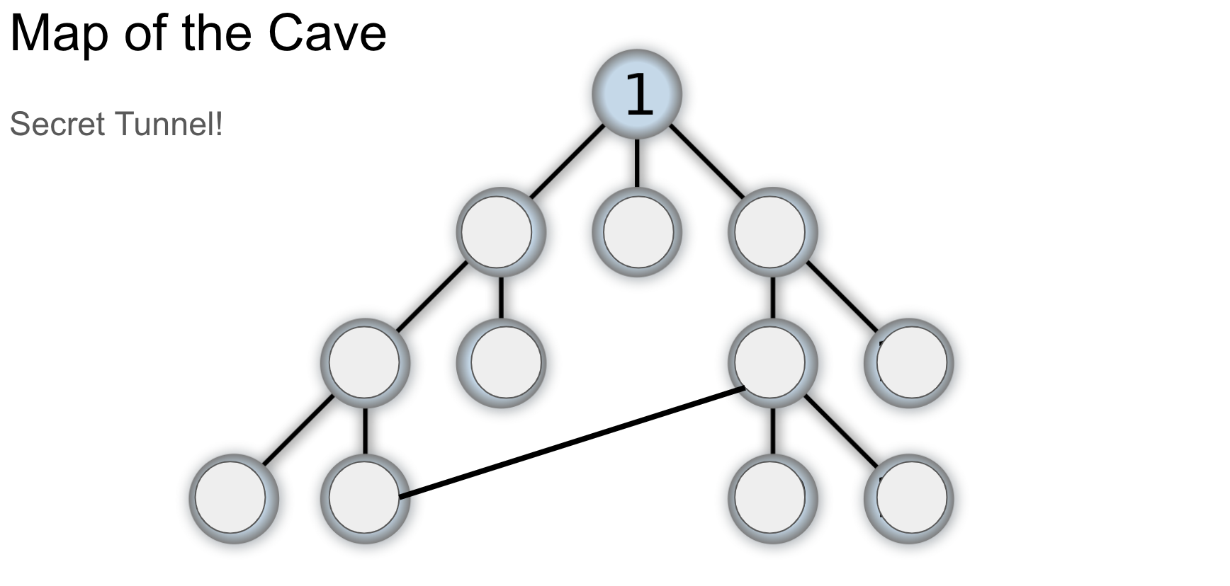

1. In red, trace the path of the BFS if the solution (key) is in the bottom-rightmost node.
2. In blue, trace the path of the BFS if the solution (key) is in the bottom-rightmost node.

|  |
| --- |
| **Subgoal Label a DFS Method (include any helper methods that you feel are necessary)** |
|  |

|  |
| --- |
| **\*EXT - Subgoal Label a BFS Method (include any helper methods that you feel are necessary)** |
|  |

**Discussion Questions: (Feel free to use this space to jot down some of your ideas prior to discussion)**

|  |
| --- |
| Describe the difference between BFS and DFS. Which one is better in your opinion, and why? |
| What is not ideal about both BFS and DFS? |

**Day 2 [A* Search]**

h = the node’s closeness to the goal(treasure)

g = the cost of traveling to that node

f = h + g

Data Set: [ 1, 2, 3, 4, 5, 6, 7, 8, 9, 10, 11, 12 ]



1. In green, trace the path of the A* search to the treasure box .
2. In orange trace the path of the A* search if the treasure box is in the bottom-leftmost node.

*(Question - *can we do this with the same h values if the treasure box moved?)

|  |
| --- |
| **Subgoal Label an A* Search Method (include any helper methods that you feel are necessary)**  **\*EXT- start writing out pseudo-code within your subgoal structure** |
|  |

**Discussion Questions: (Feel free to use this space to jot down some of your ideas prior to discussion)**

|  |
| --- |
| What is the difference between uninformed and informed search methods? |
| Why is A* generally so much more efficient than BFS or DFS? |
| What are some potential real world applications of the A* search? |